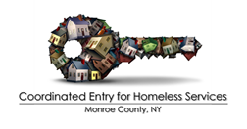

PCHO Outreach Front End Case Conference Request Form
**Please email completed form to Heidi Markham, hmarkham@letsendhomelessness.org or Kim Martin at kmartin@ccsi.org.
***If the client is already housed in the program and PCHO has closed them out you cannot request a case conference.***
Requestor Information
Name
Agency
Phone
Email

Client Information (ONLY shared with Coordinated Entry and CoC; NOT with case conference attendees)
Name
HMIS #

Please provide a summary of the reason(s) why a case conference is being requested

What steps have been taken to address the concerns noted in the summary above?

Please list all relevant parties that need to be involved in this case conference.

For questions or if you need more information, please contact:
Heidi Markham | Prioritization List Coordinator
Partners Ending Homelessness
C: (585) 866-9375 | hmarkham@letsendhomelessness.org
ADMIN USE ONLY
Date request received

Case conference approved | ☐ YES ☐ NO
Case conference ID #

Date of case conference

Other attendees invited

