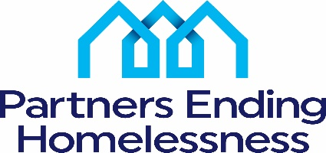
2022 Appeals Process
An applicant must submit an appeal in writing to Partners Ending Homelessness (PEH) by the appropriate deadline by email to: Charles Bollinger – cbollinger@letsendhomelessness.org
Persons who can appeal:
Only an authorized representative from the grantee organization that submitted the renewal application may request an appeal.
Grounds for an Appeal
- Applicants who believe they were denied the right to participate in the local application process
- Applicants who believe there was a data or calculation error in determining their score for the Renewal Project Ranking Criteria
- Applicants who believe decisions made were unsubstantiated regarding the amount of project funding awarded or projects were partially or fully eliminated
Deadline for an Appeal
June 16, 2022 – Appeal(s) based on ground #2
TBA - for appeals based on grounds #1 and #3. Deadline will be determined once HUD has released its 2022 CoC Program NOFO.
Phase 1: Applicant, PEH staff and at least three members of Rating and Ranking Committee will meet to hear appeal. Goal of Phase 1 is to reach agreement on a resolution of all appealable issues presented.
Phase 2: Phase 1 participants will be joined by at least two PEH non-conflicted Board members who have not previously been involved in the 2022 application review process. Phase 2 participants will review grounds for the appeal, the basis of the actions taken and will then either vote to uphold or revoke the decision(s) made in Phase 1.
Decisions made in Phases 1 or 2 are final.
If Applicant is still not in agreement with Phase 2 results, they should review the HUD NOFA and follow instructions on how and on what grounds they can appeal to HUD.

