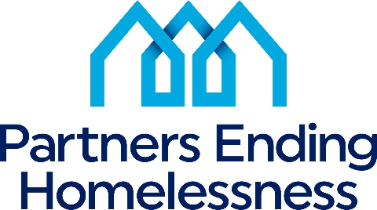
560 West Main Street
Rochester, New York 14608
585-319-5091

To: All CoC Funded Program Providers
From: Partners Ending Homelessness
Re: Notification Revised Performance Measures
Date: February 16, 2021
___________________________________________________________________

After reviewing the community outcomes for the past year in preparation for the 2021 Local Application process, we can see that some of the community goals need to be adjusted to be more in line with excellent work projects have been achieving. These changes are taking place to continue our performance growth in a positive direction and keep pace with the competitive nature of HUD CoC funding.
- Participants who have cash income will go up from 54% to 85%. On average, all CoC's project scores an 83% from 2/1/2020 to 1/31/2021.
- Participants with no income will decrease from below 20% to below 15%. On average, all CoC's project scores 17% from 2/1/2020 to 1/31/2021.
- Participants who have obtained non-cash benefits will go up from 64% to 85%. On average, all CoC's project scores 79% from 2/1/2020 to 1/31/2021.
- Participants who have health insurance will go from 80% to 90%. On average, all CoC's project scores 94% from 2/1/2020 to 1/31/2021.
Starting March 1st, 2021, these changes will take effect for the monthly reports and will be the updated measurements for the upcoming FY2021 Local NOFA.
The following updated measurement will take effect starting June 1st, 2021.
- 100% of all intake data will be entered into HMIS within 48 hours.
Ultimately, we are looking to the future for growth in our portfolio of permanent housing projects in our community that will help us end homelessness in Rochester and Monroe County.

