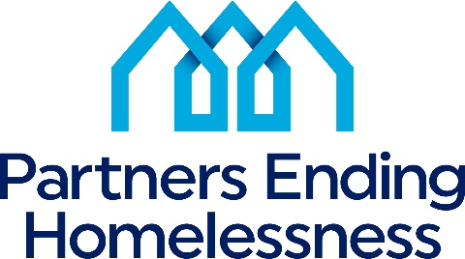
560 West Main Street
Rochester, New York 14608
585-319-5091

2022 Priorities
NY-500 Community Priorities | 2022 HUD Priorities
Prioritized Housing Components  Permanent Supportive Housing  Transitional Housing/Rapid Re-Housing  Rapid Re-Housing | End homelessness for all
Prioritized Homeless Sub-Populations  Transition Age Youth (18 -24 years old)  Chronically Homeless  Unsheltered Homeless  Families  Fleeing Domestic Violence  Re-Entry | Use Housing First approach
Prioritized Special Needs  Mental Health  Substance Abuse  Co-Occurring | Decrease numbers of Unsheltered Homeless
Prioritized PEH and HSN Activities  Improving Access to Mental Health Services  Improving Access to Substance Abuse Services  Increase PSH inventory  Increase Support Services  Increase Landlord Engagement | Increase system performance
Improving Housing Stability  Increase support services  Increase affordable housing inventory  Concern regarding number of evictions post eviction moratorium  Alternative housing for people who have been unsuccessful in PSH | Partnering with Housing (specifically PHAs), Health and Service Agencies
 | Racial Equity
 | Inclusion of persons with lived experience in local planning process

