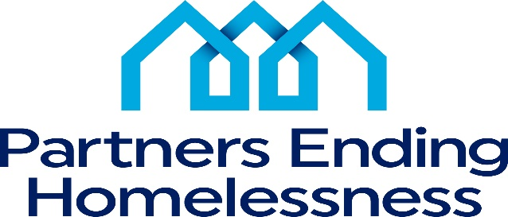 | 560 West Main Street, Rochester, New York 14608  Phone: (585)319-5091, Fax: (585)319-5488

Corrective Improvement Plan

CIP Basic Information
Partners Ending Homelessness annually monitors CoC-funded programs to ensure compliance with HUD and Community program standards. The Corrective Improvement Plan (CIP) seeks to address any deficiencies discovered during the annual project monitoring by requesting that projects provide a Plan to correct specific deficiencies. All projects that earn below 65 out of a possible 103 points on their annual monitoring are required to complete this Plan. Complete the following chart and submit one copy with the CIP.
Agency Name:
Program Name:
Grant Identification # | NY
Operating Year: | 2022 (APR ending in 2021-22)
Point of Contact
Email
Date of CIP emailed
Date of one-week follow-up due
Date of follow-up site visit:
Number of Corrective Improvement issues

Corrective Improvement Summary
Complete one chart for each non-performing objective identified in the Performance Indicator Chart.
Problem / Need / Situation
Goal | Activities | Timeline / Goal Dates | Outputs | Outcomes

