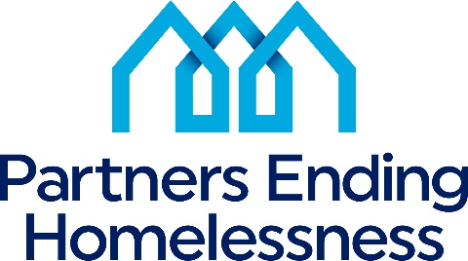
560 West Main Street
Rochester, New York 14608
585-319-5091

To: All CoC Funded Program Providers, CoC Stakeholders, and Community
From: Partners Ending Homelessness
Re: FY2023 Ranking
for HUD Funded Renewal Projects Criteria
Date: May 2, 2023
___________________________________________________________________

In anticipation of the release of the 2023 HUD CoC Program NOFO, the Partners Ending Homelessness is beginning the local ranking criteria and local application process for new and renewal projects.

2023 Local information

Annual Renewal Demand (ARD) – $14,038,378
Tier One funding is anticipated to be 94% of ARD, $12,823.779

Renewal Projects:

Projects that score above the 75% of the highest projects community average criteria score will be ranked in Tier 1 by score and will require no further review.

The bottom 25% of projects that fall below the average community score must complete Part 2 of the rating criteria, Mitigating Factors, and present it to the Project Review Committee. (PEH will email
the applicable projects once the initial scores are calculated.)

Projects will be ranked as follows:
Project's Total Score (+/-) 5 points based on mitigating factors presented to the Project Review
committee

Renewal Projects could fall and be placed into Tier 2 or reallocated if the Project Review Committee finds the project does not meet local priorities or HUD requirements.

(Please note that a project asked to complete the mitigating factors and asked to present are not automatically in Tier II.)

New Projects:

$682,116 Bonus Project funding should be available assuming 5% of FPRN as in 2022
There is likely to be a DV-RRH Bonus for Rapid Re-Housing working exclusively with victims of
domestic violence.
2023 Renewal Application Timeline

May 2: Release of Renewal ranking criteria materials.
The APR renewal data set will be run from 4/1/2022 to 3/31/23 to score performance.

May 4: Renewal project applicant Workshop.
10:00 am – 11:30 am on Zoom

May 11: All Non-cash benefits documents must be submitted to Charles Bollinger by 5 pm.

May 19:
Projects notified of scores and requested mitigating factors for the bottom 25% of projects that score below the community ranking criteria average.
Projects at or above the community average will be asked to submit their 2023 budget workbook.

May 24: Discrepancies with rating criteria score must be submitted to PEH.
May 26: Renewal ranking criteria mitigating factors for projects are due at COB (5 pm).
Week of June 5: Renewal project presentations
June 14: Notification of scores sent to presenting renewal projects.

2023 New Project Applications

HUD is expected to release its NOFO in July.
The consolidated application is due 0n August. The new project local NOFO, will follow this timeline contingent on the HUD release. If HUD requests an earlier date, the timeline will be accelerated.

Tentative timeline after HUD's NOFO is released.

TBA: Release of New Project applications five days after the HUD NOFO release.
TBA: New Project applicant workshop
TBA: All questions regarding New Projects due to PEH
TBA: Final Q&A for New Projects posted to the PEH website.
TBA: New Project applications are due 14 business days after the applicant workshop on new applications.
TBA: New Project application presentations.
TBA: Release of Ranking and Awards
TBA: Request of final appeals due after new project funding is released.
TBA: Release of Final Ranking and Awards
TBA: Esnaps upload training
TBA: Upload into Esnaps for all ranked projects Renewal and New

All materials are available on HSN Website once released to the community
www.letsendhomelesseness.org
Direct questions to Charles Bollinger III – CoC Programs Coordinator
(Email only) at cbollinger@letsendhomelessness.org

