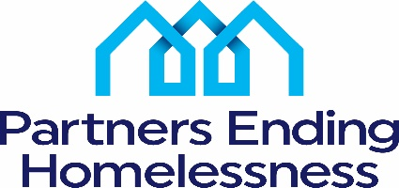
2023 Appeals Process
An applicant must submit an appeal in writing to Partners Ending Homelessness (PEH) by the appropriate deadline by email to: Charles Bollinger – cbollinger@letsendhomelessness.org
Persons who can appeal:
Only an authorized representative from the grantee organization that submitted the renewal application may request an appeal.
Grounds for an Appeal
- Applicants who believe they were denied the right to participate in the local application process
- Applicants who believe there was a data or calculation error in determining their score for the Renewal Project Ranking Criteria
- Applicants who believe decisions made were unsubstantiated regarding the amount of project funding awarded or projects were partially or fully eliminated
Deadline for an Appeal
May 26, 2023 – Appeal(s) based on ground #2
TBA - for appeals based on grounds #1 and #3. The deadline will be determined once HUD has released its 2022 CoC Program NOFO.
Phase 1: The applicant, PEH staff, and at least three Rating and Ranking Committee members will meet to hear the appeal. The goal of Phase 1 is to reach an agreement on resolving all appealable issues presented.
Phase 2: Phase 1 participants will be joined by at least two PEH non-conflicted Board members who have not previously been involved in the 2023 application review process. Phase 2 participants will review the grounds for the appeal, the basis of the actions taken, and then either vote to uphold or revoke the decision(s) made in Phase 1.
Decisions made in Phases 1 or 2 are final.
If Applicant still does not agree with Phase 2 results, they should review the HUD NOFA and follow instructions on how and on what grounds they can appeal to HUD.

