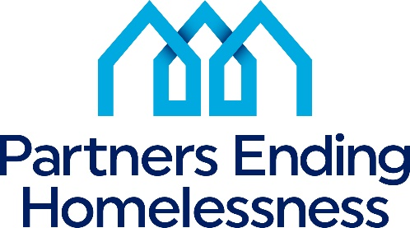

2023 Reallocation Process
Per the CoC Program, "Reallocation is a process that the CoC uses to shift funds in whole or part from existing eligible renewal projects to create one or more new projects without decreasing the CoC's ARD" that will better address the needs of the homeless. Conversely, reallocation can reduce or eliminate funding from existing renewal projects. The CoC Ranking and Review Committee, a non-conflicted group of CoC Board and community members, makes final reallocation decisions based on the following:
- The project has a history of not spending down all requested HUD funds during the contract year. Unspent funds are reallocated for new projects
- A project voluntarily decides not to renew its project
- A project voluntarily requests its existing program(s) funding be reallocated to create a new project that meets a community's needs. In this instance, assuming the project meets threshold requirements, the new project created is prioritized for inclusion in Tier 1
- A program has a history of not meeting performance measures and has not followed through with a performance improvement plan. This may include both outcome measures and utilization.
- A project which has deficiencies in the ongoing operation of the programs

