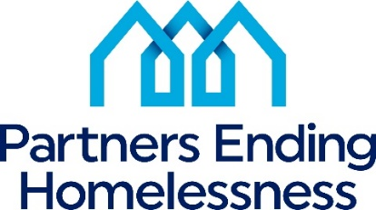

2023 Priorities
NY-500 Community Priorities | 2023 HUD Priorities
Largest Unmet Need Housing/Service Components  Permanent Supportive Housing  Emergency Shelter  Prevention/Diversion Services  Transitional Housing  Transitional Housing/Rapid Re-Housing  Rapid Re-Housing  Street Outreach  Other | End homelessness for all  Use Housing First approach  Decrease numbers of Unsheltered Homeless  Improving system performance  Partnering with Housing (specifically PHAs), Health and Service Agencies  Racial Equity  Improving Assistance to LGBTQ+ Individuals  Inclusion of persons with lived experience in local planning process  Increasing affordable housing supply
Prioritized Homeless Sub-Populations
Chronically Homeless
Families
Unsheltered Homeless
Re-Entry
Transition Age Youth (18 -24 years old)
Fleeing Domestic Violence
Veterans
Other
Prioritized Special Needs
Mental Health
Chronic Health Conditions/Physical Disability
Substance Abuse
Developmental Disabilities
Employment Services
Aging (55+)
Other
HIV/AIDS
Prioritized PEH and HSN Activities
Increase PSH inventory
Increase Landlord Engagement
Community Event – more social than training to bring awareness to homelessness
Increased Training Opportunities
Increase Communication and Coordination Across Systems
Advocacy
Increased resources for Prevention

Improving Housing Stability
Increase PSH/affordable housing resources
Increase support services
Increase cash assistance for housing related costs – rental arrears, security deposits, etc.

