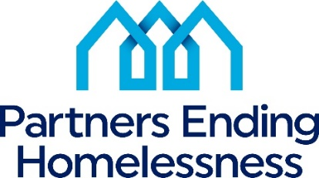

2024 Priorities
NY-500 Community Priorities | 2024 HUD Priorities
Largest Unmet Need Housing/Service Components  Permanent Supportive Housing  Emergency Shelter  Transitional Housing  Prevention/Diversion Services  Transitional Housing/Rapid Re-Housing  Rapid Re-Housing  Street Outreach  Other | End homelessness for all  Use Housing First approach  Decrease numbers of Unsheltered Homeless  Improving system performance  Partnering with Housing (specifically PHAs), Health and Service Agencies  Racial Equity  Improving assistance to LGBTQ+ individuals  Involvement of Persons with Lived Experience at all levels of the CoC  Building an Effective Workforce  Increasing Affordable Housing Supply
Prioritized Homeless Sub-Populations
Families
Chronically Homeless
Unsheltered Homeless
Transition Age Youth (18 -24 years old)
Fleeing Domestic Violence
Re-Entry
Veterans
Other
Prioritized Special Needs
Mental Health
Chronic Health Conditions/Physical Disability
Substance Abuse
Developmental Disabilities
Employment Services
Aging (55+)
Other

Barriers to Housing
Affordability
Availability
History of Prior Evictions/Poor Landlord References
Bad Credit
Units that meet HQS standards
Accessibility (Mobility)
History of Criminal Justice Involvement
Discrimination
Other
Improving Housing Stability
Increase PSH/affordable housing resources
Increase support services
Increase cash assistance for housing related costs – rental arrears, security deposits, etc.

