THE HOMELESS SERVICES SYMPOSIUM
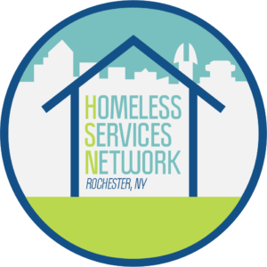
PEOPLE HELPING PEOPLE –
EMPOWERMENT THROUGH HOPE!!
Friday, June 20, 2025
8:15am – 12:30pm at Nazareth University

8:30 – Introduction and welcome with light refreshments

9:00 – 10:00 Keynote: Faith and Our Community – Empowerment Through Hope. Speaker: Deacon David Palma

10:15 – 11:15 Three Workshops
Faith Based panel – How do We Inspire?
Community Based Outreach – Making the Connections.
Paddling Forward in Troubled Waters – How do we Advocate?

11:30 – 12:30 Three Workshops
Empowerment, Dignity and Integrity – Keeping our Purpose.
Streets to Work – Assisting the Difficult Transition.
The Allusive Balance Between Work, Life and everything else.

Location: Nazareth University
Cost $30
Registration info: https://letsendhomelessness.org/homeless-services-network/hsn-2025-symposium-registration/

