**Ice Cream Social**

Date: Thursday, July 31, 2025 Time: 11:00 AM to 12:30 PM

Location: St. Joseph’s Park (Clinton Ave)

(Rain Date: August 7, 11:00 AM - 12:30 PM)

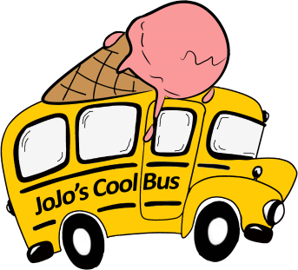

Join us as JoJo’s Cool Bus Ice Cream serves up some delicious

treats at St. Joseph’s Park! Other items that will be available include peanut butter and jelly sandwiches, water, clothing, personal care products, and much resourceful information.

***Sponsored by the Sisters of St. Joseph and the Homeless Outreach Team***