Monroe County

CODE BLUE 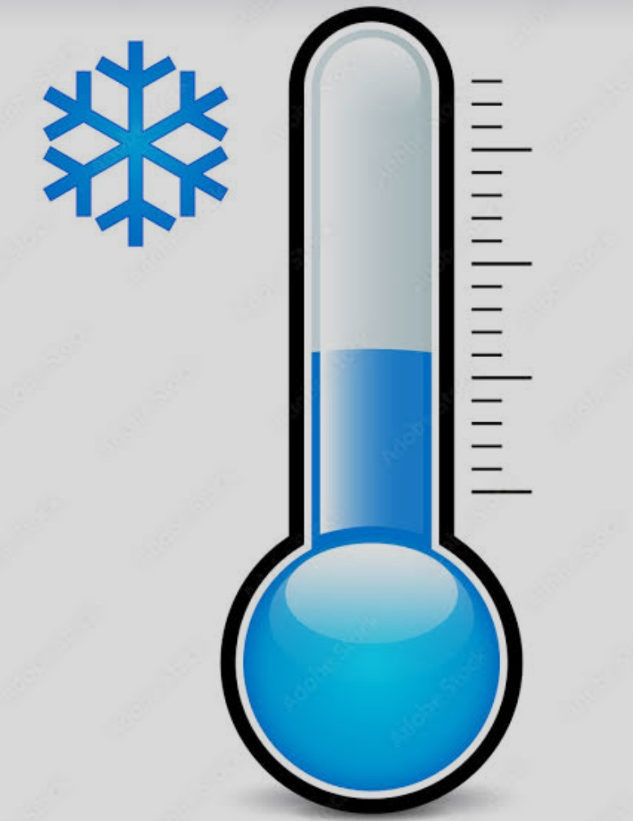
AVAILABLE 24/7
Warming Center Locations
Grace House – Men Only House of Mercy
1140 Norton Street 285 Ormond Street
Rochester Rochester
RTS Routes: 4, 5 RTS Routes: 3
585-750-7261 585-546-2580

Open Door Mission Oak Orchard
156 N Plymouth Avenue First Baptist
Rochester 124 Main Street
RTS Routes: 15, 21 Brockport
585-423-1825 585-340-1355
Open Mon. – Thurs. 8PM to 8AM, Fri. 5 PM to 8AM and Saturday 2PM through Monday at 8AM

Free RTS Transportation to Warming Centers
www.myrts.com

