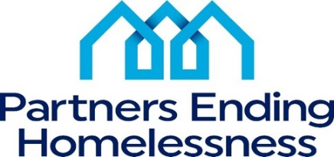

Please join us on Tuesday January 13, 2026, for the
Partners Ending Homelessness Annual Meeting for 2025.

The agenda will include:

- Governance & Nominating Committee
- FY 2025 NOFO update
- Community Reports:
  - Homeless Services Network
  - Coordinated Entry
  - Chronic Homeless Workgroup
- Executive Director report
  - 2025 Accomplishments
  - Community Issues to be tackled in 2026
- Board of Directors report

