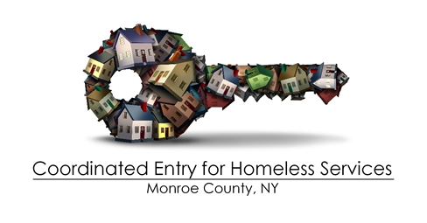
2025 in Review
- In the last program year:
  - 2389 de-duplicated households were placed on the prioritization list.
  - 2244 were exited from the prioritization list;
  - 740 households were referred to CoC/ESG housing programs.
- Implemented the new Homelessness Assessment Tool (HAT) in June 2025
  - Community-wide input and support
  - Subcontracted with Causewave Consulting and Crossroads Insights
- New Training requirement for anyone accessing the Prioritization List
  - HAT training is required prior to accessing the Prioritization List
  - Offering ZOOM online trainings until online training can be completed and uploaded to the PEH learning platform
  - Annual in-person training required: next offering in May of 2026
- Supported the allocation of a HMIS data Import tool from Wellsky,
  - Import data from Mission Tracker to HMIS
    - Increases the accuracy of reported homeless
    - Supports 2 of our community’s largest shelters, decreasing the need to “double report”

