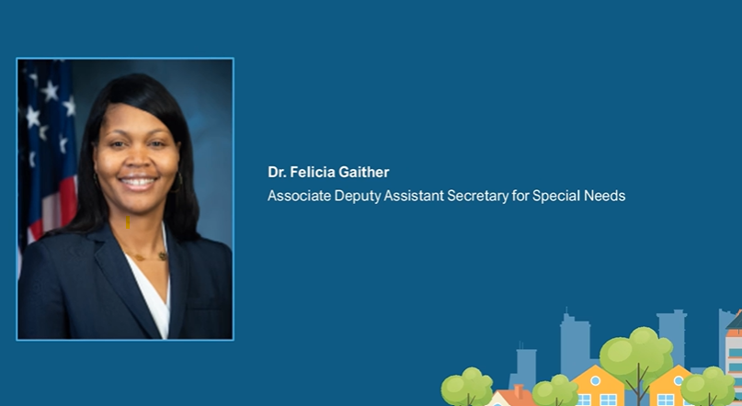
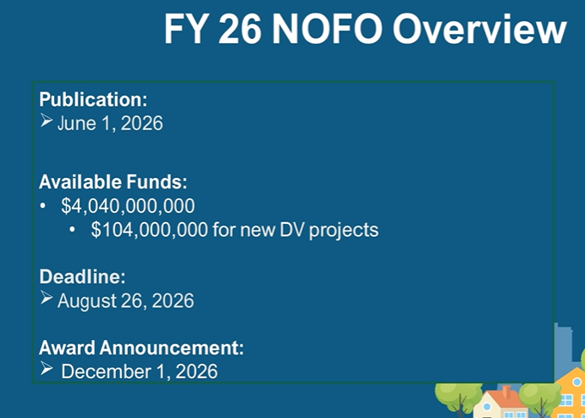

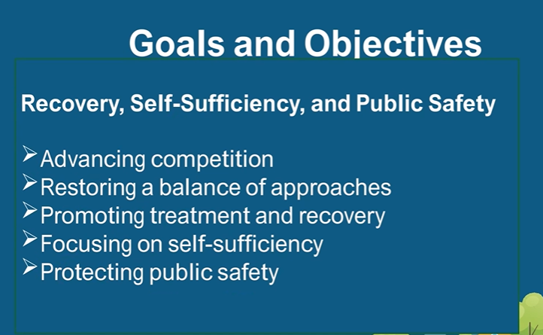
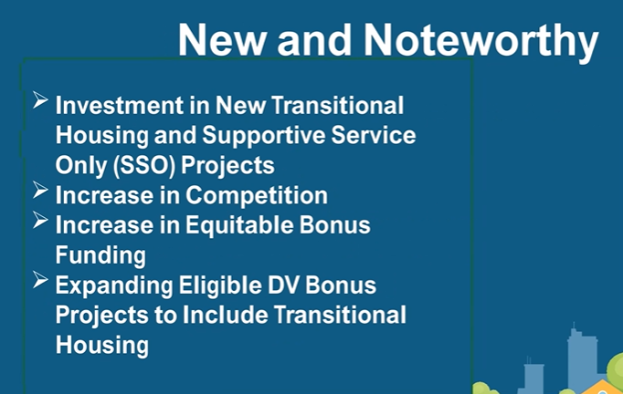
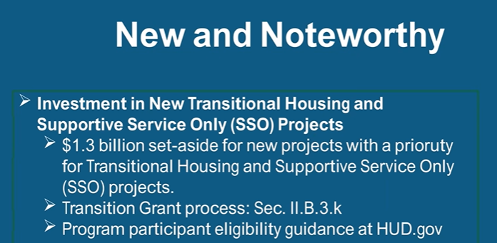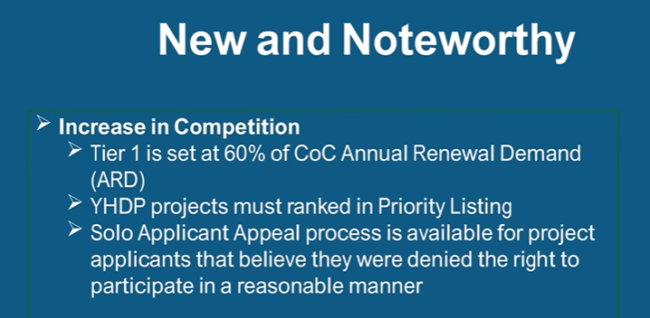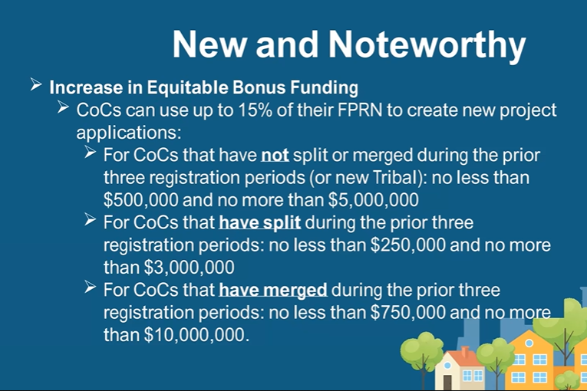
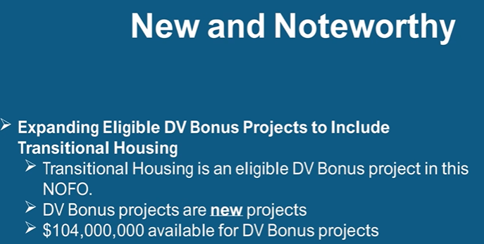

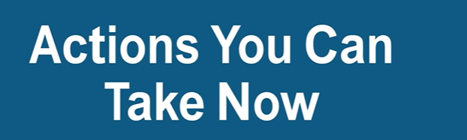
It’s important to complete these tasks prior to your application. They can sometimes be time-consuming so please begin asap.
- The tasks in the slide below are completed in e-snaps. e-snaps is the electronic Continuum of Care (CoC) Program Application and Grants Management System used by the U.S. Department of Housing and Urban Development (HUD). It is an online portal operated by HUD's Office of Special Needs Assistance Programs (SNAPS) to support the annual application and funding process for homeless assistance programs. For more information, you can visit the e-snaps page on the HUD Exchange and the e-snaps 101 Toolkit page
- If you need assistance with e-snaps, please email Melissa Marrone at melissa@marroneconsulting.com
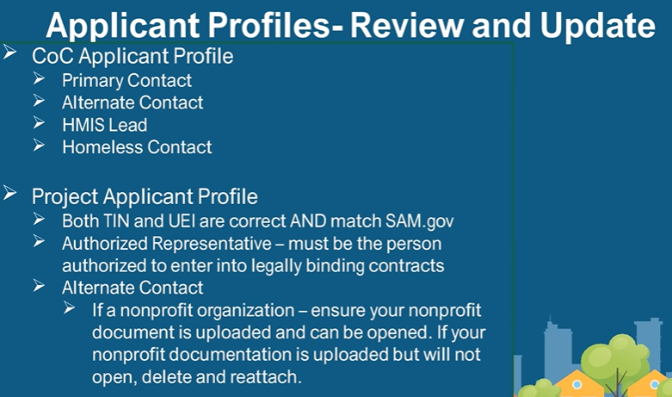

- If you are renewing or applying for federal dollars, you must be registered with sam.gov. SAM.gov (System for Award Management) is the official free, U.S. government-operated website used to manage the federal award lifecycle. It is primarily used by businesses, non-profits, and organizations to register to do business with the federal government, apply for grants, and bid on contracts.
- Key Considerations
  - Cost: Registration and all services on SAM.gov are free.
  - Renewal: Registrations must be updated every 12 months to remain active.

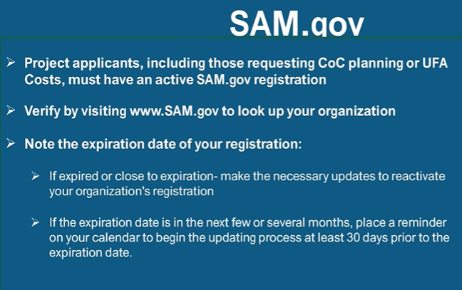

Code of Conduct for HUD Grant Programs
