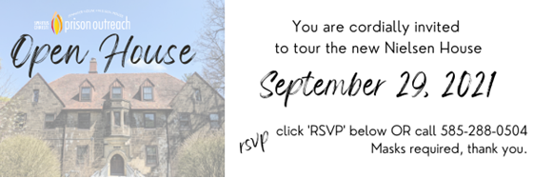

3PM - 7PM

Blessing: 4PM

223 Sawyer Street (parking lot)

30 Millbank Street (street parking )

RSVP:

[scastronovo@spirituschristipo.org](mailto:scastronovo@spirituschristipo.org)