[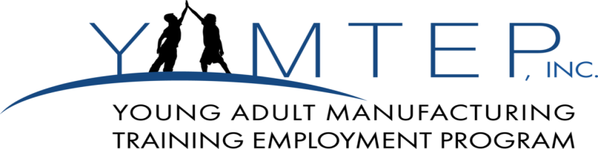](http://yamtep.com/)

**“Your Jobs Employment Training Program”**

**Employment Placement Success Rate = 75%**

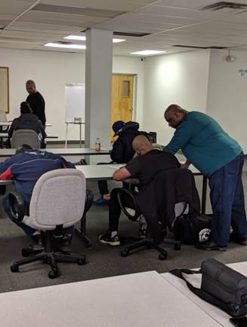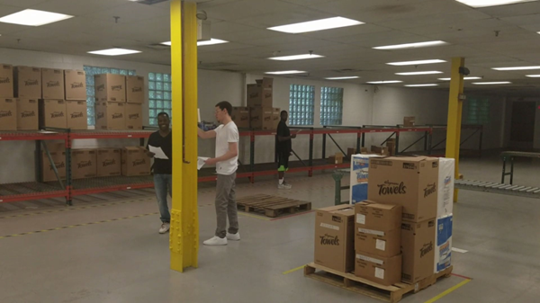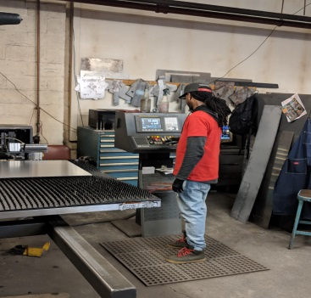 No Skills / Low Skills Forklift Working

**3 Week Training Program Schedule:**

**July 12th – July 28th Aug. 2nd – Aug. 18th**

**Aug. 23rd – Sept. 8th Sept. 13th – Sept. 29th**

**Course offerings:**

•         **Forklift training**

o   Students will have safe and good driving skills on a forklift that would support requirements of a manufacturing or warehousing factory

o   Goal – all students will pass a forklift licensing exam (those that do not pass will receive a certificate of participation defining the number of hours spent training on a forklift).

•         **Basic skills manufacturing**

o   Beginning shop math

o   Blue print reading and precision calipers

▪  2D prints only

**Contact Information:**

282 Hollenbeck St.

Rochester NY, 14621

Phone: 585-467-5279

▪  Using calipers (how to hold and read)

▪  Working with quality docs (terminology and use)

▪  Part quality management (Calipers)

•         **Soft Skills – Job readiness**

o   Resume Writing

o   Interview best practices